**Daily Scrum or Standup Meeting**

Team name: Team 08

Scrum Master: Hannah Howell

Date:Oct 21

|  |  |  |  |
| --- | --- | --- | --- |
| **Team Member** | **What did you do since the last Scrum?** | **What do you plan to do before the next scrum?** | **What obstacles do you have?** |
| Hannah Howell | Reviewed Django tutorial  Had a good weekend off | Jump into the programming itself.  Estimate doing half of the sprint tasks before Wednesday. | Finding the time to do it |
| Garrett Johnson | Reviewed Django tutorials.  Updated Python to 3.7.5.  Installed Django. | Implement item and auction models. | More review of Django needed. |
| Zion Steiner | * Completed Django and Vue tutorials * Looked into Vuetify | * Figure out bidder/admin accounts, permissions | Should we use Django built-in admin panel or make a custom one? |
| Tristan Thomas | - Reviewed what I had missed from last meeting  - Updated IDE and Python  - Pulled Project  - Reviewed Project and sprint backlog | - Review HTML and Django  - HTML for Login, Signup, and Forgot Password pages | - OS program to work on |
| N/A |  |  |  |

# Burndown

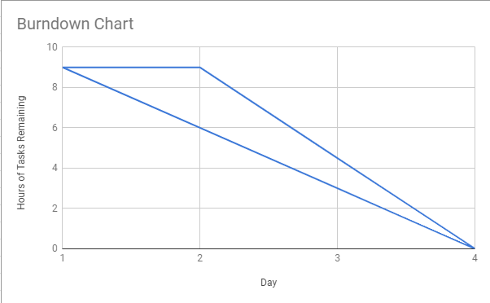

# Screenshot of you project board

